Tab 1
I’m reaching out to a developer to help build an AI assistant that can streamline my daily sales workflow.
My current process is very manual. I search for nursing homes (target audience) in a specific city, record the business name and phone number, then call the facility to ask who is responsible for managing the visitor log. During the call, I try to obtain the appropriate contact name and email so I can send a follow-up outreach email.
What I would like to build is an AI-assisted workflow that helps speed this up.
Ideally, I could place my cursor over a business listing (for example from a search result or directory), click a button, and have the business information automatically transferred into my GoHighLevel CRM as a new contact. From there, I want to be able to log my call actions for the day and schedule the next follow-up task for that contact directly inside GoHighLevel.
It would also be helpful if the system could identify the business’s LinkedIn or Facebook page and surface those links so I can reach out to them there as well.
—----------------------------------------------------------------
Yes. The part inside your own workflow is very buildable.
The LinkedIn/Facebook outreach part is where the wheels get wobbly. LinkedIn explicitly prohibits third-party software, bots, browser extensions, or scripts that scrape data, send messages, add contacts, or automate activity on LinkedIn, and says accounts can be restricted or shut down for it. GoHighLevel, on the other hand, does have developer APIs and OAuth-based integration support, so pushing contact data, notes, and follow-up tasks into GHL is the clean part of this build.
Here is the practical answer:
What you can build safely
A small browser-based sales assistant that helps you work faster while you stay in control.
Workflow
- You search nursing homes by city.
- You hover or highlight a business listing.
- You click a button like “Send to GHL”.
- The agent captures:
  - business name
  - phone number
  - website
  - city/state
  - source page
- It creates or updates the contact/company in GoHighLevel.
- It opens a little action panel so you can log:
  - called
  - reached front desk
  - asked for visitor log contact
  - got email / no email
  - left voicemail
  - send follow-up on X date
- It creates the next task automatically in GHL.
That part is very realistic.
What I would build for you
A browser extension + lightweight backend.
Front end
- Chrome extension
- floating button when you’re on Google search results, Maps, directory sites, or business websites
- one-click capture to GHL
- quick action buttons for call outcomes
Backend
- connects to GoHighLevel API
- deduplicates contacts
- creates notes
- schedules next tasks
- optionally tags leads like:
  - Nursing Home
  - Westminster
  - Called
  - Need Email
  - Follow Up 3 Days
Optional smart features
- email finder from public company website pages like Contact, About, Admissions, Administration
- AI note cleanup so your notes become consistent
- suggested next action based on what happened on the call
- daily dashboard:
  - new leads added
  - calls made
  - emails collected
  - follow-ups due tomorrow
Best version of this for your workflow
Do not make it fully autonomous right away. That is how people end up with a fancy robot that creates a beautiful mess.
Build it in phases:

Phase 1 — fastest ROI
Click-to-capture lead into GHL
- name
- phone
- website
- address/city
- source URL
- quick note
- next follow-up date
This alone saves a lot of time.

Phase 2
Call outcome assistant
After each call, you click one status:
- wrong number
- receptionist only
- got decision-maker name
- got email
- no email
- call back later
Then it auto-creates the note and next task in GHL.

Phase 3
Website research helper
The agent visits the company website and looks for:
- admin email
- contact form
- admissions/contact page
- social links
- LinkedIn company page
- Facebook page
Then it gives you a review screen before saving.

Phase 4
Semi-automated outreach
- draft email in GHL
- prepare LinkedIn/Facebook page URLs for manual review
- maybe prepare message drafts for you to paste manually
That is the compliant route. Less sexy, more durable. Old-school rule still wins: the account you do not get banned is the better account.
What I would not recommend
I would not recommend a bot that:
- scrapes LinkedIn profiles
- sends LinkedIn connection requests automatically
- sends LinkedIn DMs automatically
- auto-clicks around Facebook from your personal account
- mass-posts or mass-messages from accounts without approved integrations
That is exactly the kind of thing that gets flagged. LinkedIn says those tools violate its rules.
Better approach for social
Instead of “AI reaches out on LinkedIn/Facebook for me,” do this:
- agent finds public social profile URLs
- agent saves them to GHL
- agent drafts outreach copy
- you review and send manually, or use approved business tools where allowed
That still saves time without playing chicken with platform policies.
Recommended tech stack
- Chrome Extension for click-to-capture
- Node.js backend for API calls
- GoHighLevel API for contacts, notes, tasks, tags, workflows
- OpenAI API for note standardization, next-step suggestions, email drafting
- Postgres or Supabase if you want your own lead queue outside GHL
- Playwright only for your own controlled browser workflows, not for automating prohibited social actions
What to tell the coder
Tell them you want:
A Chrome extension and backend that lets me capture business info from search results or websites with one click, push it into GoHighLevel, log call outcomes, add notes, tag contacts, and schedule the next follow-up task automatically. The system should also research the business website for public contact info and social profile links, then present those for review. It should not automate LinkedIn or Facebook actions that violate platform policies.
That wording keeps the project sharp.
Here is a cleaner version you can send the coder:

Project Brief: AI Sales Workflow Assistant
I need a tool to streamline my daily outbound sales process for nursing homes.
Current workflow
- I search nursing homes in a specific city
- I save the business name and phone number
- I call and ask who handles the visitor log
- I try to get the correct contact name and email for outreach
- I want to track my actions and next follow-up inside GoHighLevel
What I want built
- A browser extension or web tool that lets me click or highlight a business listing and send the business info into GoHighLevel
- Capture fields such as:
  - business name
  - phone number
  - website
  - address/city
  - source URL
- Create or update the contact/company in GoHighLevel
- Let me quickly log actions such as:
  - called
  - left voicemail
  - asked for visitor log contact
  - got contact name
  - got email
  - no answer
  - wrong number
- Automatically create notes and schedule the next follow-up task for that contact
- Optionally research the business website for public emails, contact pages, LinkedIn company page, and Facebook page, then save those results for review
- Optional AI support for:
  - cleaning up notes
  - suggesting next steps
  - drafting follow-up emails
Important
- The system should integrate cleanly with GoHighLevel API
- The system should avoid automating LinkedIn or Facebook actions that violate platform rules
- I prefer a simple workflow with one-click capture and fast follow-up logging
Goal
Reduce the time it takes to research, call, log notes, and schedule next actions for each lead.

Tab 2
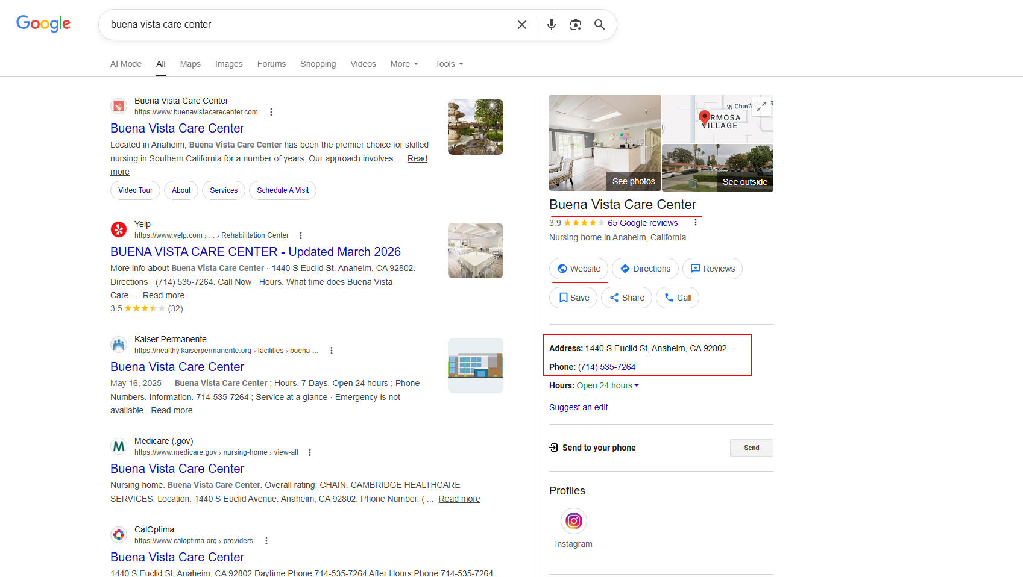
I would like to know how much info i can put to Gohighlevel by just putting my cursor over it. Here I can see that we would need:
Business Name,
Website
Address
Phone
Instagram account

